
FRESH TEACHER'S E-LIBRARY
BEGINNING OF TERM III EXAMINATION 2023
P.5 SOCIAL STUDIES & RE
Time Allowed: 2hours 15 Minutes
Pupil’s Name: …………………………………..………………………
Class: ………………………………………………………………………
School Name: ………………………………………………………….
FOR EXAMINERS’

USE ONLY

Qn. No. | MARKS | EXR’S  No.
1 - 10
11 – 20
21 – 30
31 – 40
41 – 43
44 – 46
47 – 49
50 - 52
53 - 55
TOTAL

Read the following instructions carefully:
- This paper has two sections: A and B
- Section A has 40 questions (40 marks)
- Section B has 15 questions (50 marks)
- Answer all questions. All the working for both sections A and B must be shown in the spaces provided.
- All working must be done using a blue or blackball point pen or ink. Any work done in pencil will NOT be marked except drawings and diagram.
- Unnecessary changes in your work and handwriting that cannot be easily read may lead to loss of marks.
- Do not fill anything in the table indicated
Turn Over
“For examiners’ use only” and the boxes inside the question paper.

SECTION A
- Name the building material got from swamps.
_________________________________________________________________
- Give one danger of floods to people.
_________________________________________________________________
- Which domestic animal is kept for transport?
_________________________________________________________________
- How did the coming of Arabs in Uganda promote trade?
_________________________________________________________________
- How does climate influence people’s way of dressing?
_________________________________________________________________
_________________________________________________________________
- Name the missionary who introduced cotton seeds in Uganda.
_________________________________________________________________
- Write one problem faced by Uganda as a land locked country.
________________________________________________________________
- Why did the Bantu settle in the lake regions of Uganda?
_________________________________________________________________
- Give one way in which order is kept at school.
_________________________________________________________________
- Name the mountain found in the South Western part of Uganda.
_________________________________________________________________
- How did Dr. Albert Cook promote health services in Uganda?
_________________________________________________________________
- Which type of rainfall is received in highlands?
_________________________________________________________________
- Give one way the police keeps law and order in our communities.
_________________________________________________________________
- How did the early man get food?
_________________________________________________________________
- Name one social activity practised in our community.
_________________________________________________________________
- Give one reason why Kabaka Mwanga never signed the 1900 Buganda
agreement.
_________________________________________________________________
- Why do we need forests in Uganda?
_________________________________________________________________
- Write one member of an extended family.
_________________________________________________________________

- Name the district leader in charge of domestic animals.
_________________________________________________________________
- In the space below, draw a map symbol for a rift valley

- How was Sir Samuel Baker important to the people of Northern Uganda?
_________________________________________________________________
- Why is Kabale cooler than Gulu?
_________________________________________________________________
- Name the units in which distance is measured from your district to the
neighbouring districts?
_________________________________________________________________
- Give one reason why Lake Victoria has fresh water.
_________________________________________________________________
- Which line of latitude is marked 0º?
_________________________________________________________________
- Why does Mt. Elgon favour the growing of Arabica coffee?
_________________________________________________________________
- How were the ethnic groups politically organised?
_________________________________________________________________
- Write one Natural resource which supports crop farming.
_________________________________________________________________
- Why are some rivers not used for transport?
_________________________________________________________________
- Why should every community be with a police post?
_________________________________________________________________
- Why were the British interested in colonizing Uganda?
_________________________________________________________________
- Give one reason for planting grass on our school compound.
_________________________________________________________________
- Give one reason why farmers irrigate their crops in a dry season.
_________________________________________________________________
- Mention the raw material used for making artificial fertilizers.
_________________________________________________________________
- Give one reason why most game parks are found in savannah vegetation.
________________________________________________________________
Answer Either Christianity Or Islam but not both.
- Either: Give one way Christians care for God’s creation.
_________________________________________________________________
Or: State one way Muslims care for Allah’s creation.
_________________________________________________________________
- Either: Give one way Christians benefit from fasting.
_________________________________________________________________
Or: How do Muslims benefit from fasting?
_________________________________________________________________
- Either: Why did Abraham accept to sacrifice his son?
_________________________________________________________________
Or: Why did prophet Ibrahim accept to sacrifice his son?
_________________________________________________________________
- Either: Which Prophet in the Old Testament prophesised about the birth of
Jesus at Bethlehem?
_________________________________________________________________
Or: Name the last Prophet in Islam.
_________________________________________________________________
- Either: Give one reason why Christians worship God.
_________________________________________________________________
Or: State one reason why Muslims worship Allah.
_________________________________________________________________
SECTION B
- Use the map below to answer the questions.
2
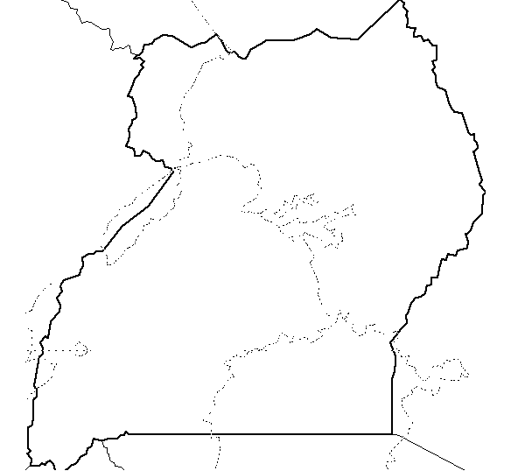

1

- Name the ethnic groups which used routes 1 and 2 when entering Uganda.
1______________________________________________________
2 _____________________________________________________
- Why did the above ethnic groups migrate from their cradle land?
- ____________________________________________________________
- ____________________________________________________________
- (a) Name the longest river in Uganda.
____________________________________________________________
(b) In which two ways can rivers be dangerous to people who live along
them?
- ____________________________________________________________
- ____________________________________________________________
(c) Name the feature on a river used to generate Hydro Electricity Power.
___________________________________________________________
- (a) What is child abuse?
________________________________________________________________________________________________________________________
(b) State any two ways in which children’s rights are abused today.
(i) ____________________________________________________________
(ii) ____________________________________________________________
(c) Give one way in which child abuse can be controlled in the districts of
Uganda.
____________________________________________________________
- (a) What is vegetation?
________________________________________________________________________________________________________________________
(b) In which two ways is vegetation important to wild animals?
(i) ____________________________________________________________
(ii) ____________________________________________________________
- Give any one example of vegetation.
____________________________________________________________
- (a) What is a project?
________________________________________________________________________________________________________________________
(b) Give two examples of projects which can be started at school.
(i) ____________________________________________________________
(ii) ____________________________________________________________
(c) State one requirement needed to start a project.
____________________________________________________________
- (a) Name the Buganda king who invited the Christian missionaries in Uganda.
____________________________________________________________

(b) A part from formal education, give another reason why missionaries were invited in Uganda.
____________________________________________________________
(c) How did the missionaries promote education in Uganda?
____________________________________________________________
(d) Give one problem faced by missionaries in Uganda.
____________________________________________________________
- (a) Match A and B correctly.
Kintu and Nambi Bagisu
Mundu and Sera Acholi
Gipiir and Labongo Baganda
(b) Give one reason why legends should be taught to children.
___________________________________________________________
- (a) State any two types of leaders in a district.
- ___________________________________________________________
- __________________________________________________________
(b) In which two ways are leaders got in a district?
(i) ____________________________________________________________
(ii) ____________________________________________________________
- (a) Name two physical features in Uganda which were formed by faulting.
- ____________________________________________________________
- ____________________________________________________________
(b) Why do highlands attract many people for settlement
(i) _____________________________________________________________
(ii) ___________________________________________________________
- (a) What is a nation?
________________________________________________________________________________________________________________________
(b) Which people made Uganda a nation?
____________________________________________________________
(c) How did the above people make Uganda a nation?
(i) ___________________________________________________________
(ii) ___________________________________________________________
Answer Either Christianity Or Islam but not Both.
- EITHER:
- Who delivered the Israelites from Egypt?
____________________________________________________________
- Why did God choose the above person to deliver the Israelites?
- ______________________________________________________
- ______________________________________________________
- Write one problem faced by the Israelites to the Promised land
____________________________________________________________
OR:
- Who delivered Allah’s people from Egypt?
____________________________________________________________
- Why did Allah choose the above person to deliver his people?
- _______________________________________________________
- _______________________________________________________
- Which problem was faced by the Allah’s people on their way to the Promised land?
____________________________________________________________
- EITHER:
- Name the Holy Book for Christians.
____________________________________________________________
- How is the above book different from other books?
- ___________________________________________________________
- ____________________________________________________________
- In which part of this book do we find the story of creation?
____________________________________________________________
OR:
- Name the Holy Book for Muslims.
____________________________________________________________
- How is the above book different from other books?
- _______________________________________________________
- _______________________________________________________
- Give one importance of the above Holy Book to Muslims.
____________________________________________________________
- EITHER:
- Why did God send the floods?
____________________________________________________________
- How did Noah save his people from the floods?
____________________________________________________________
- Mention any two sons of Noah.
- _________________________ (ii) ______________________
OR:
- Why did Allah send the floods?
____________________________________________________________
- How did Nuhu save his people from the floods?
____________________________________________________________

- Give any two sons of Nuhu
- _______________________ (ii) ______________________
- EITHER:
- Give two reasons why God created man.
- ____________________________________________________________
- ____________________________________________________________
- How did man disobey God?
____________________________________________________________
- How do people disobey God today?
____________________________________________________________
OR:
- Give two reasons why Allah created man.
- ____________________________________________________________
- ____________________________________________________________
- How did man disobey Allah?
____________________________________________________________
- How do people disobey Allah today?
____________________________________________________________
- FOR BOTH
- What is Authority?
________________________________________________________________________________________________________________________
- State any two types of authority.
- ____________________________________________________________
- ____________________________________________________________
- How do leaders misuse their authority?
____________________________________________________________

********END*******

